1 | 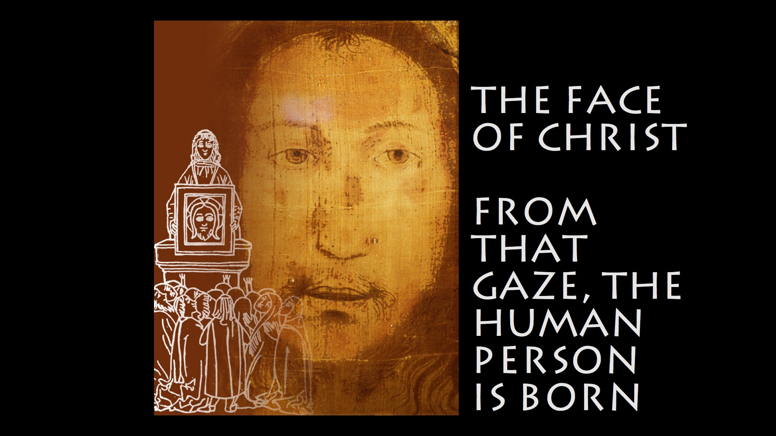
2 | 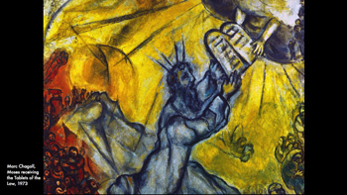 | The desire to see God's Face, the Face of He who moves everything runs through the Old Testament.  As the Psalmist says, "Your face, O Lord, I will seek".  But this Face was not known to the chosen people: when Moses asked God to show him His face, He replied that it was not possible because no human person can see God and remain alive.  Moreover, to prevent the desire to see Him from being corrupted, it was forbidden for the Jews to fabricate any representation of God.  This prohibition was maintained in Christianity…
3 | 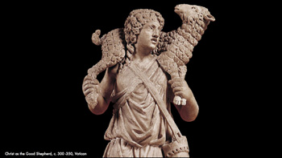 | …  in the first centuries, Christ was represented with symbolic images, like that of the Good Shepherd.  But around the fourth/fifth century, the prohibition to image God was lifted and within a short time a certain face with unmistakable features began to appear...
4 | 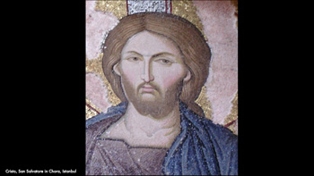 | …  in the East...
5 | 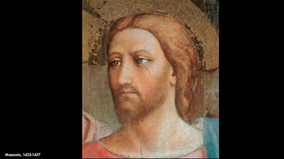 | … and in the West. (Nothing similar happened for Our Lady; indeed, portraits of her differ considerably one from the other. )  What was the cause of this doctrinal and artistic change?  According to the Eastern Fathers, the answer is both simple and surprising: "Christ himself left His image to the Church" (George of Cyprus).  The Church thus preserves a portrait of Christ, which according to all accounts, was impressed on a piece of cloth.  Our exhibition tells the story of this portrait in the desire to become aware of what it means for us that Christ himself left this gift to his own.
6 | 
7 | 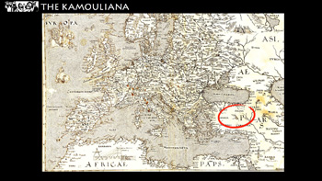 | The story of a miraculous portrait (acheiropoeton - not made by human hands) begins in Cappadocia, today's Turkey, in the time of the Roman Emperor Justinian (482-565) in the little town of Kamouliana, which was later to give its name to the image.  The portrait allegedly appeared to answer the wish of a Greek woman, Hypatia, who couldn't believe in Jesus without seeing him.
8 | 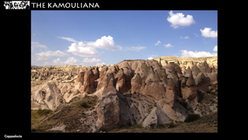 | The Fathers called the town of Kamouliana "new Bethlehem", making a link with the mystery of the Incarnation.  The Kamouliana reached Constantinople in 574 and became an imperial banner accompanying the emperor in his campaigns in Africa and Persia (586-622).
9 | 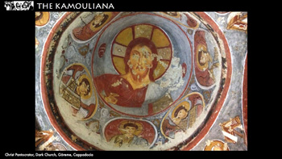 | There is no extant reproduction of the Kamouliana. Sources describe Christ's face as being 'neither woven nor painted'. News about the Kamouliana fades out shortly before the iconoclastic struggles.
10 | 
11 | 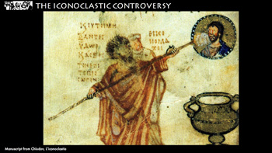 | In the war against sacred images (which is the meaning of the term 'iconoclastic'), the conflict revolved around the mystery of Christ's nature.  …
12 | 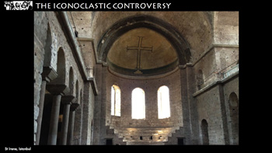 | …  According to the iconoclasts, only Christ's humanity could be depicted, so any representation meant dividing the unity of His Person.
13 | 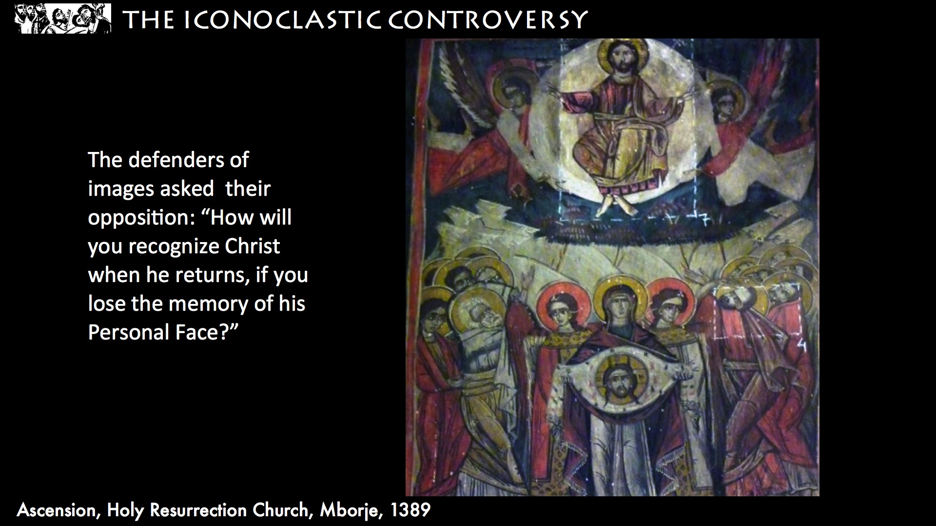 | (For the defenders of images, to deny the possibility of representing Christ meant denying the very reality of His incarnation.)  (ON THE SLIDE) They ask their opposition: "How will you recognize Christ on His return if you lose the memory of His personal face?"
14 | 
15 | 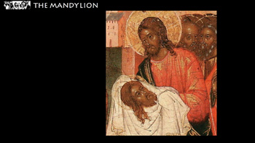 | (During the Nicean Council of 787) as an argument in favour of icons the Fathers cite the Mandylion, which was to become the most famous acheiropoieton of the East: the cloth on which Christ himself imprinted his face as a gift to King Abgar. “Mandylion” means towel in Arabic.
16 | 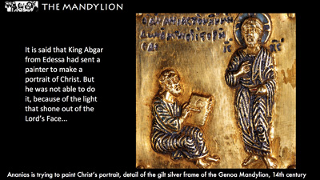 | The story of the portrait was summarized thus by John of Damascus:  (ON THE SLIDE) "It is said that King Abgar from Edessa had sent a painter to make a portrait of Christ. But he was not able to do it because of the light that shone forth from the Lord’s face...
17 | 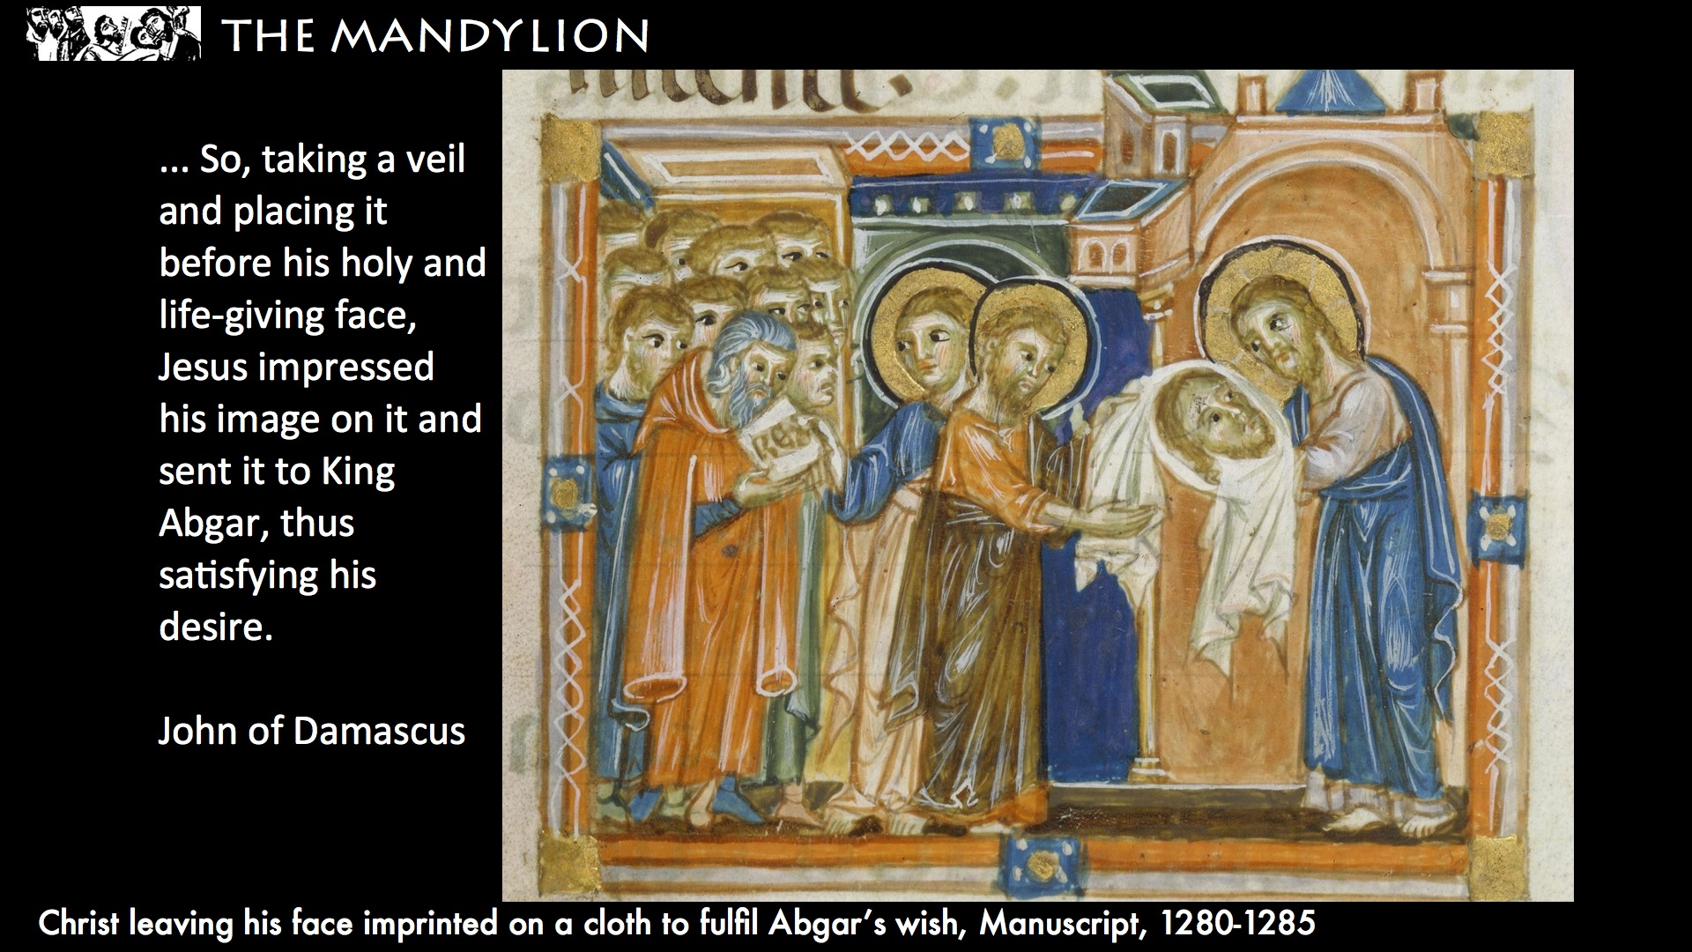 | ...(ON THE SLIDE) So, taking a veil and placing it before his holy and life-giving face, Jesus impressed his image on it and sent it to King Abgar, thus satisfying his desire."  In Syrian sources, King Abgar’s ambassadors are identified with the Greeks who ask Philip if they can see Jesus in the twelfth chapter of St John's Gospel (Jn 12:20-21)
18 | 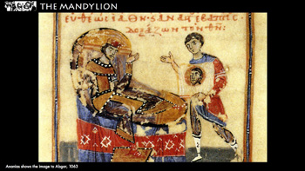 | King Abgar, healed by the prodigious image, places it on the gates of his city as a protection. With the return of paganism, the image was hidden by a stone and forgotten.
19 | 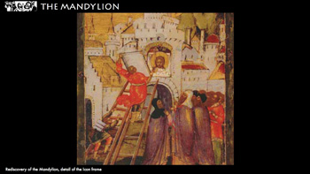 | It was rediscovered 4 centuries later (between the fifth and sixth centuries).
20 | 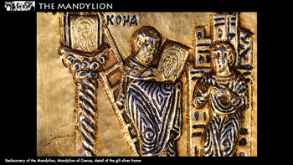 | Impressed on the stone closing the niche, a second copy of the miraculous portrait was found. This was called the Keramion (“tile”).
21 | 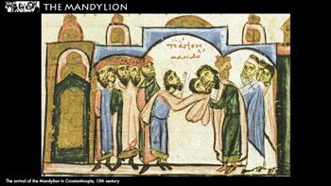 | In 944, amidst great celebrations among the people, the Mandylion was taken to Constantinople.  Emperor Constantine VII wondered about the moment in which the image was formed and hypothesized it was in the Garden of Olives.  The source which traced the image back to King Abgar was therefore not a certain one, and perhaps the Mandylion showed evidence of a living, suffering Jesus.
22 | 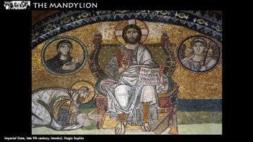 | In Constantinople the Mandylion brought about a small artistic and liturgical revolution.  Because of its uniqueness as a portrait left to us by Christ, the Holy Face became the prototype of all icons of Christ.
23 | 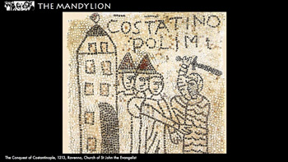 | In the eleventh century the break with the Churches of the East was sanctioned.  In 1204 Constantinople was conquered and sacked during the fourth senseless crusade of Christians against Christians.  Robert de Clary described the Mandylion and the Keramion in the imperial chapel.
24 | 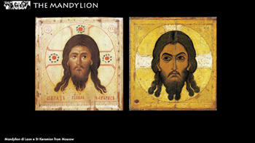 | In reproductions, the differences between the Mandylion (on canvas) and the Keramion (the tile) lie in their backgrounds: the fringes indicate the towel of the Mandylion and the ochre yellow the clay of the Keramion.  In the face, the differences between the two icons can be seen in the direction of the gaze and the little tuft of hair which falls on the forehead and which seems to want to underline the fact that one is the mirror image of the other. The eyes and hair on the Mandylion face right, and on the Keramion they face left.  After 1204, no Eastern Church claimed to possess an achaeropoetos of Christ's face.  At this point, the story of the Holy Face moves to the West.
25 | 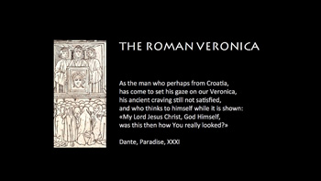 | And here is the third acheiropoetos of Christ, the Roman Veronica, which was to be the most important relic in Christianity from the twelth to the fifteenth century.  (ON THE SLIDE) As the man who perhaps from Croatia,  has come to set his gaze on our Veronica,  his ancient craving still not satisfied,  and who thinks to himself while it is shown:  “My Lord Jesus Christ, God Himself,  was this then how You really looked?”  Dante, Paradise, XXXI
26 | 
27 | 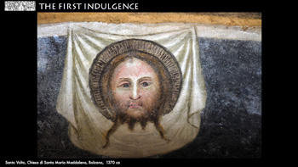 | In medieval Europe reproductions of a sudarium (a napkin or cloth for wiping the face) conserved in St Peter’s in Rome were to be found everywhere, on which the portrait of Christ was miraculously impressed, a “sudarium which the people called Veronica”.  However, historians share no certainties about how and when the relic arrived in Rome.
28 | 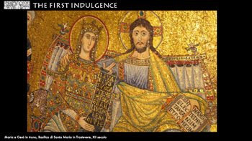 | The "Veronica’s" international fame undoubtedly began in 1208 when Pope Innocent III established a procession with the sudarium on the Sunday after the Epiphany, the liturgical day dedicated to the Wedding at Cana.  The wedding banquet creates a link, which never fails throughout its history, between the Eucharist and the Veronica, the contemplation of which is considered nourishment for the eyes.
29 | 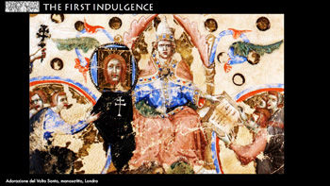 | In 1216, at the end of the procession, the image turned upside down. The Pope, disturbed by this, composed a prayer to be recited in honor of the relic, and instituted an indulgence linked to the recitation of the prayer.  This is the first indulgence in the history of the Church linked to an image.
30 | 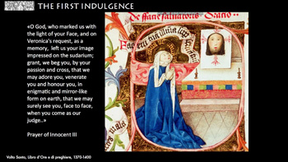 | The indulgence could also be obtained in front of a copy, and this was to be one of the reasons for the spreading of the Veronica all over Europe.  (ON THE SLIDE "O God, who marked us with the light of your Face, and on Veronica's request, as a memory, left us your image impressed on the sudarium; grant, we beg you, by your passion and cross, that we may adore you, venerate you and honour you, in enigmatic and mirror-like form on earth, that we may surely see you, face to face, when you come as our judge." )
31 | 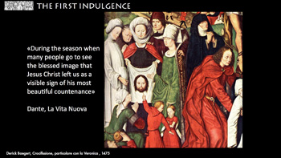 | The detail of these altarpieces with the Veronica veil surrounded by pilgrims is a clear reference to the exposition after the Octave of the Epiphany, which also Dante cites in the “Vita Nuova”:  (ON THE SLIDE) “During the season when many people go to see the blessed image that Jesus Christ left us as a visible sign of his most beautiful countenance”  But what is the meaning of an indulgence linked to a gaze?  We all share the experience of our being increased when we meet a human gaze.  This “realising” gaze was also attributed to Christ.
32 | 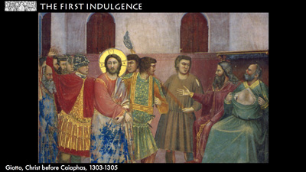 | St Ambrose attributed Peter’s tears of repentance, after denying Jesus, to Christ’s gaze.
33 | 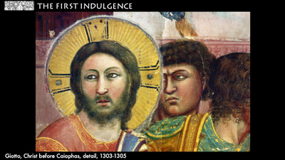 | And St Jerome wrote: If Christ had not had in his face and eyes a star-like splendor, the Apostles would not have followed him so promptly.  This “transforming power” works also when faced with a portrait of Christ.
34 | 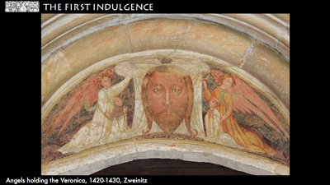 | The frontal view of Christ’s face on the linen of the Veronica, more than any other image, brings about this exchange of gazes between Christ and the faithful.
35 | 
36 | 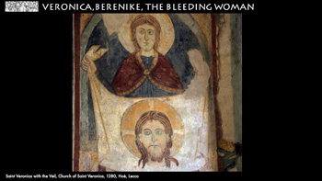 | The oldest representation of Saint Veronica is a fresco from 1280.  But who was she?  There is no mention of a woman named Veronica in the canonical gospels.  In the twelfth century poets and writers looked for the origin of the story of the woman mentioned in the papal prayer in the apocryphal gospels.
37 | 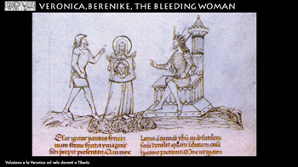 | The subject of the apochryphal “Cycle of Pilate” is Jesus’ trial. In the oldest version of the text, a woman named Beronike comes forth to speak, and turns out to be the woman with the issue of blood healed by Jesus. Given that she is a woman, her testimony is challenged by the Jews and declared null. In later versions, Veronica’s ‘part’ is embroidered further: she had had a portrait of the Lord painted, and because of this portrait was taken to Rome to heal emperor Tiberius who was ill with leprosy. Finally, in the twelfth century the origin of the portrait is miraculous.
38 | 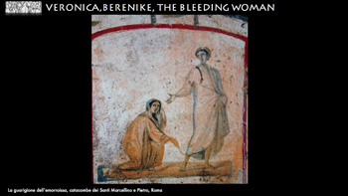 | The bleeding woman is present in the most ancient pictorial cycles and Beronike is also cited by Eusebius of Caesarea (265-340).  The etymology of Veronica as “true icon” (composed by the Latin term “vera” and the Greek “eicon”) appears only at the end of the thirteenth century. Although the anagram has met with favorable fortune, it is thought unlikely that at the origin of the woman named Veronica there is a medieval play on words.
39 | 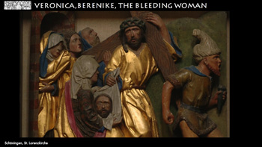 | Only in the fourteenth century the impressing of Jesus’ face onto Veronica's veil takes place on the way to Calvary.  According to the new sentiments inspired by St Francis, Christ’s gift was no longer the answer given by the Son of God to satisfy king Abgar’s or Veronica’s desire, but was the Redeemer’s reward for the compassionate gesture of a woman who loved him to the point of jeopardizing her own life.
40 | 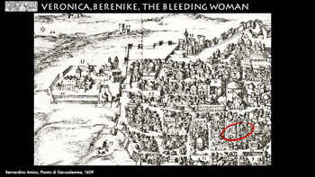 | And in the fourteenth century, the place of the meeting between Christ and the Veronica was identified in Jerusalem, marked in pilgrims’ drawings as a little staircase.  Thus, while the memory of the woman healed by Jesus goes back to the fourth century, the tradition of her encounter with Christ in Jerusalem appears ten centuries later.
41 | 
42 | 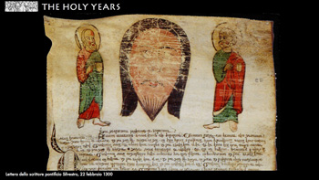 | On February 22, 1300, Boniface VIII convoked the first Holy Year which was to see an “immense, boundless flow of peoples coming to obtain the plenary indulgence”.  On the parchment you can see a miniature of the Face of Christ between the small figures of Saints Peter and Paul, as a symbol of the last steps of the Jubilee pilgrimage.
43 | 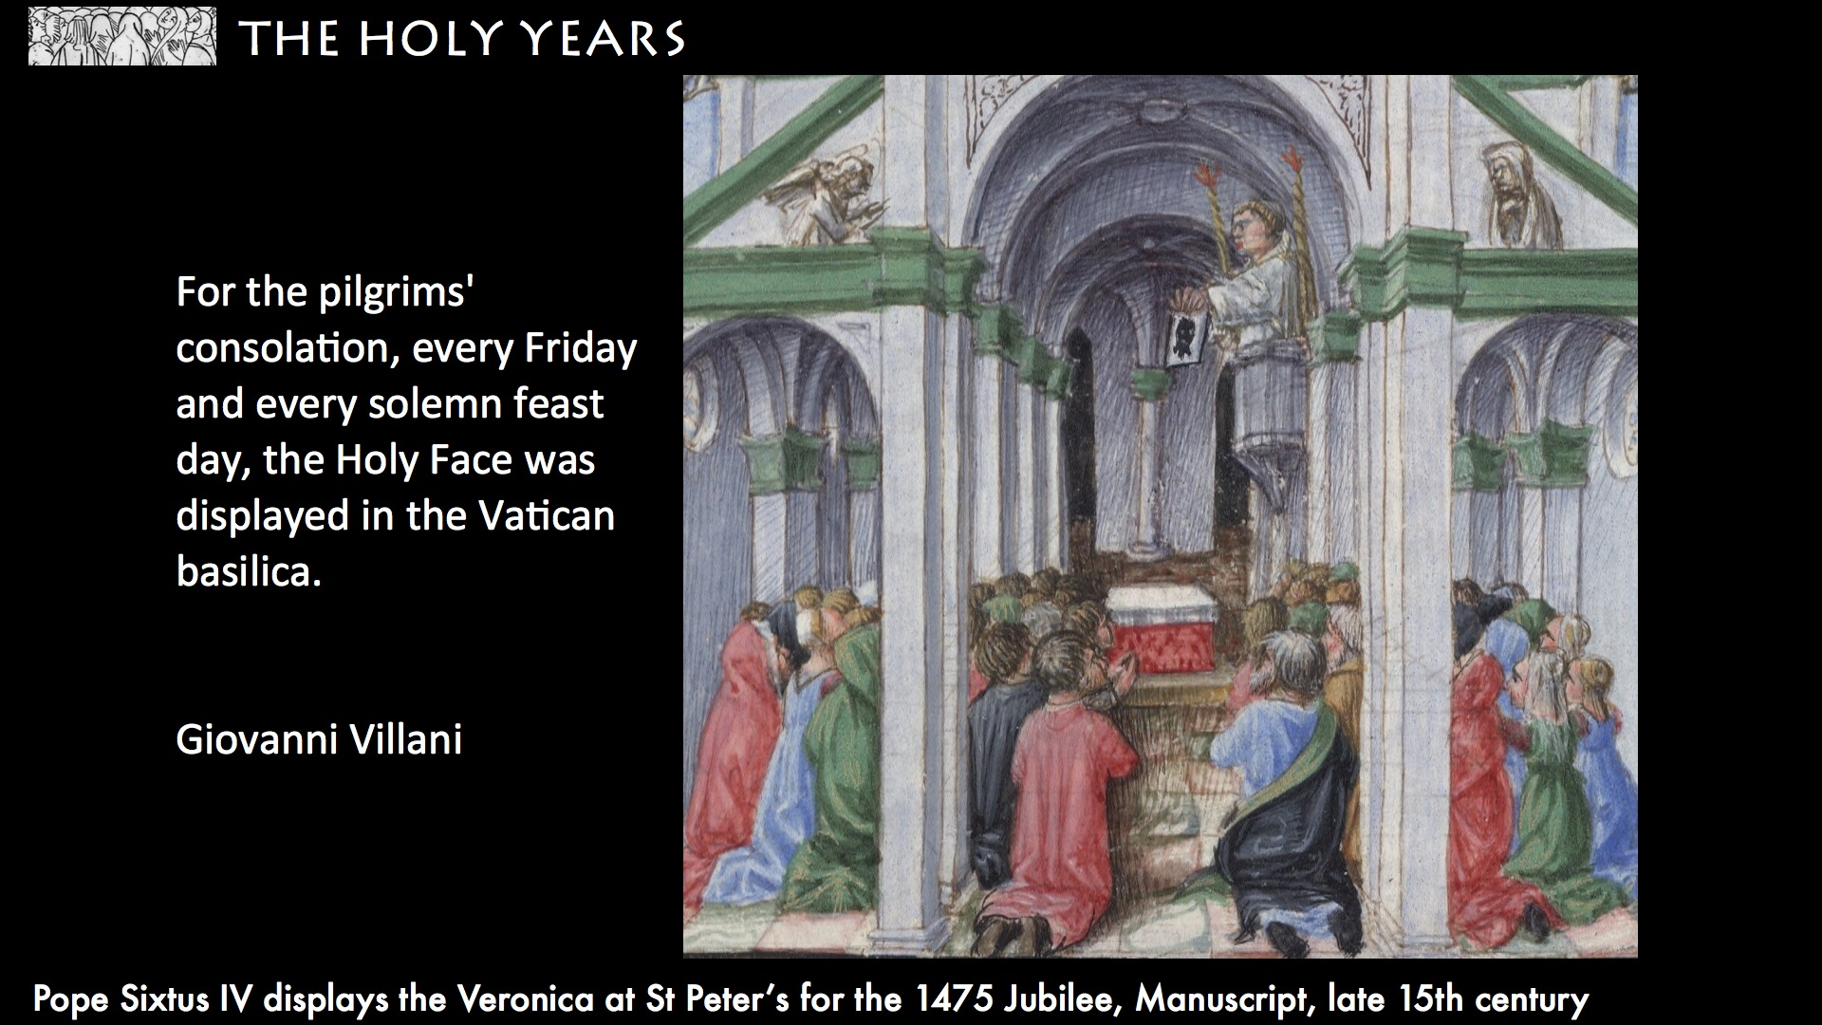 | As a matter of fact, to obtain the indulgence, it was necessary to visit the tombs of Saints Peter and Paul, but the culmination of the pilgrimage was to see the face of Christ impressed on the Veronica veil.  As Giovanni Villani wrote: (ON THE SLIDE) “For the pilgrims' consolation, every Friday and every solemn feast day, the Holy Face was displayed in the Vatican basilica".
44 | 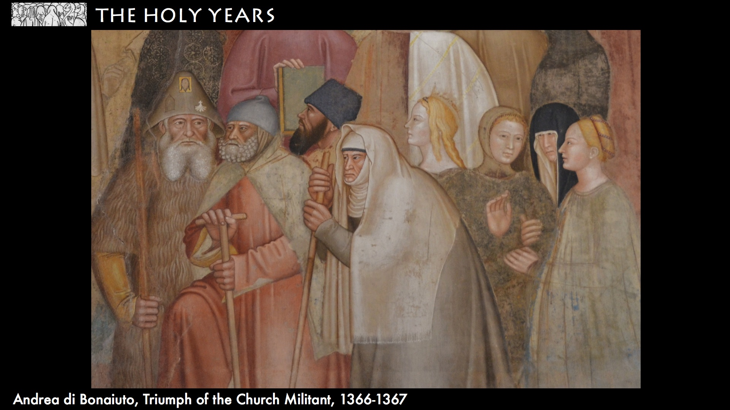 | Although large crowds (many many people) were present when the Veronica was shown, and it could be dangerous - we know that a monk called William from Derby died in Rome in such a crush -  ...
45 | 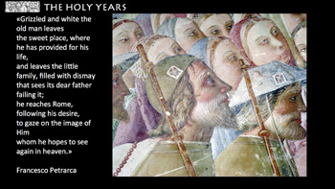 | ... poets and artists stress the meeting with Jesus of each pilgrim, face-to-face.  At the time - Dante mentions it in the Divine Comedy - there was widespread awareness that in the Face of Christ the destination of my own face is mirrored.  (ON THE SLIDE) “Grizzled and white the old man leaves the sweet place, where he has provided for his life, and leaves the little family, filled with dismay that sees its dear father failing it; he reaches Rome, following his desire, to gaze on the image of Him whom he hopes to see again in heaven.”
46 | 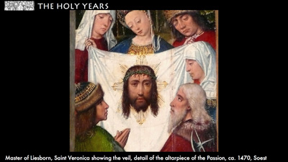 | I arrive at this destiny of similarity to him through a process of adjustment which is added to every time I look on him and let myself be looked on by Him.
47 | 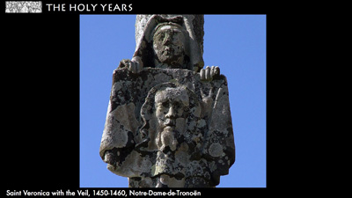 | This is why St Gertrude the Great suggests we should often stay in front of Him...  ... indeed, from the 14th century on, copies of the Veronica could be seen everywhere.
48 | 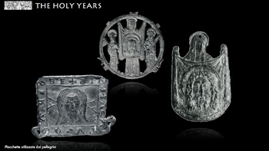 | Small tin badges called veronicas (vernicles), which marked pilgrims to Rome, have been found all over Europe.
49 | 
50 | 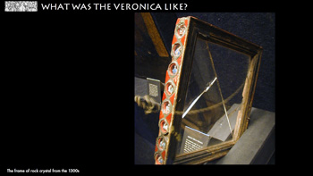 | Considering the numerous copies made of it, it seems amazing that we know little of what the Veronica looked like, other than the size which we can gather from a frame of rock crystal (the biggest slab of this crystal in existence) given by three Venetian noblemen for the Jubilee of 1350.
51 | 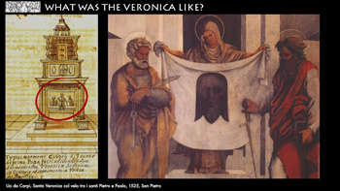 | The difficulty lies in the divergence between the reproductions of the Veronica. In many - like in this, made for the altar of the Veronica itself in 1525 - the color of his face appears almost black, creating a similarity with the representations of the Mandylion.
52 | 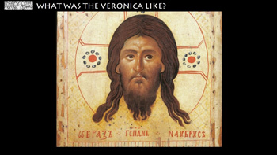 | There must have been a similarity between the Mandylion and the Veronica. This can be deduced from the fact that in 1249, the future pope Urban sent this copy of the Mandylion to his sister, the abbess of the convent of Montereuil-en-Thiérache who had asked him for a Veronica. In the accompanying letter, he asks her to welcome it “like the Holy Veronica, that is, as its true image and effigy.”
53 | 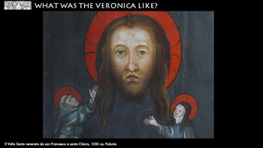 | If we want to identify the characteristics of the Veronica, which cannot be inferred from the copies of the Mandylion, firstly, we can often find an open mouth with visible teeth.
54 | 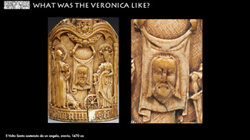 | This characteristic can be considered a sign of authenticity if one considers the difficulty imposed on artists. Like in this Peace of ivory, where the Holy Face is only 1 inch high.
55 | 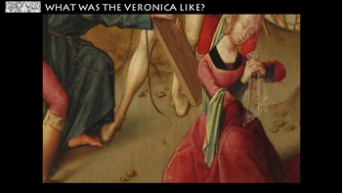 | A second characteristic is the transparent effect which, from the fifteenth century on, is used by artists to indicate precious clothes, such as the veils of our Lady and Baby Jesu. Thus Flemish painters in particular substituted an impalpable veil for the heavy towel of the Mandylion.
56 | 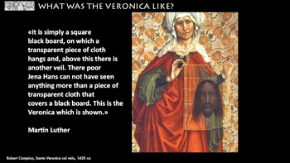 | Also Martin Luther, who visited Rome in 1510, defined it “a pale linen”  (ON THE SLIDE) “It is simply a square black board, on which a transparent piece of cloth hangs and, above this there is another veil. There poor Jena Hans can not have seen anything more than a piece of transparent cloth that covers a black board. This is the Veronica which is shown.”
57 | 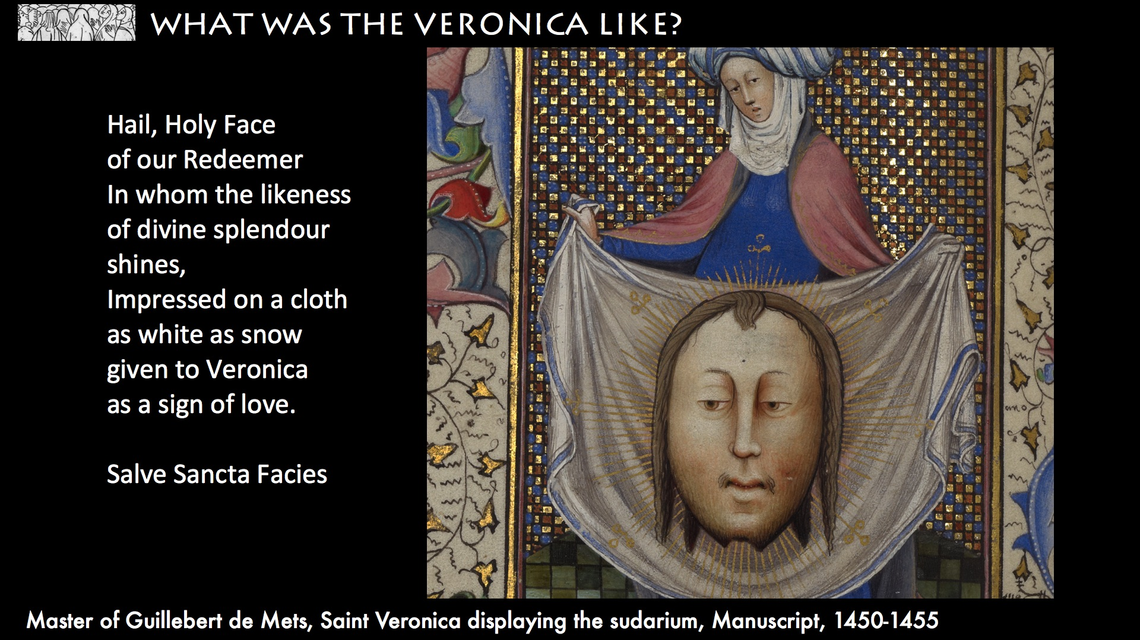 | A third characteristic is the luminosity. It’s described in the hymn Salve Sancta Facies (1316-1334) who defines the face of Christ impressed on the snow-white cloth as transfigured.  (ON THE SLIDE)  “Hail, Holy Face / of our Redeemer / In whom the likeness / of divine splendour shines, /  Impressed on a cloth / as white as snow / given to Veronica /as a sign of love.” (Salve Sancta Facies)
58 | 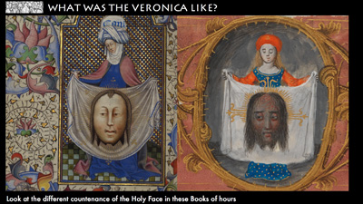 | The fourth characteristic is the Signs of Suffering and drops of blood.  That two-fold appearance may look strange, but already in the thirteenth century we find notes about that.  Gertrude the Great, writes that, just as in Christ there is the passion and the resurrection, thus the Veronica is at the same time dark and luminous.  And the English mystic, Julian of Norwich (1342-1416), writes:  “The face impressed upon Veronica’s veil, which is situated in Rome, changes colour and countenance, sometimes appearing more comfortably and life-like, sometime more ruefully and death-like, as anyone can see.”
59 | 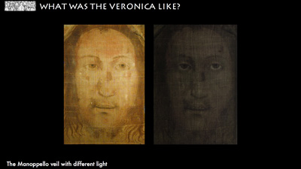 | These descriptions would lose their enigmaticity if the Veronica were similar to the Manoppello veil.  According to the light, anyone can see that Christ's face on the veil can either be serene and luminous or scared and dead-like.  Exactly as Julian of Norwich described it 700 years ago.
60 | 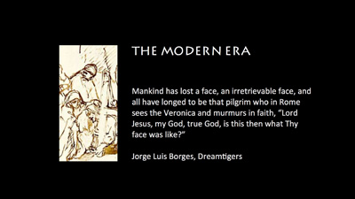 | (ON THE SLIDE)  Mankind has lost a face, an irretrievable face, and all have longed to be that pilgrim who in Rome sees the Veronica and murmurs in faith, “Lord Jesus, my God, true God, is this then what Thy face was like?”  J.L. Borges Dreamtigers
61 | 
62 | 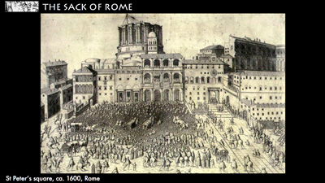 | On 19 April, 1506, the first stone of the new basilica of St Peter’s, wanted by Pope Julius II, was laid. The stone was placed where one of the gigantic pilasters supporting the cupola would stand, the one that would be called “the Veronica pillar” because it preserve the Roman relic within it.
63 | 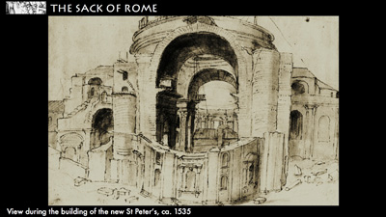 | The beginnings of the work that was to demolish the previous basilica which had been standing for twelve centuries was extremely controversial. Moreover, the indulgences decreed by Julius II for whoever gave alms for the building were to become one of the pretexts for what would be the most serious crisis in the history of the Western Church.
64 | 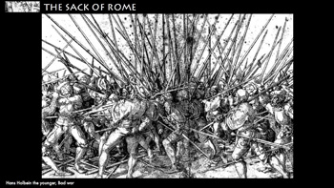 | On May 6,1527, the mercenaries of Charles V of the Hapsburgs conquered and sacked Rome. During the sack of the city, rumors spread that the Veronica had been stolen.
65 | 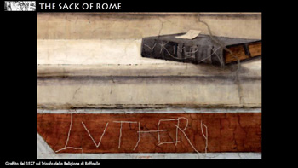 | The fear was not ungrounded: the papacy's link with the Veronica and the widespread devotion to it drew the Reformers' indignation.
66 | 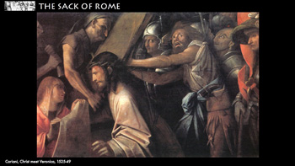 | In the following years, reports of the loss of the relic were denied and the expositions began again, but attitudes toward the relic had changed. In 1582 St. Veronica was cancelled from the list of martyrs.  Many artists started to paint a white sudarium, or a veil held by a woman in such a way that it was impossible to see anything on it.  Lastly, some sudariums were painted on which the features of the face could barely be distinguished.
67 | 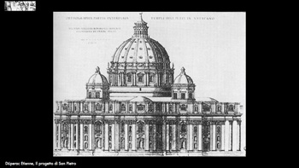 | On the evening of March 21, 1606, the Veronica was placed with the major relics under Michelangelo's grandiose cupola to indicate that the Church is sustained by the Redeemer’s Passion.  But the physical reality of the Veronica moved into second place and stopped being the object of passionate devotion by pilgrims.
68 | 
69 | 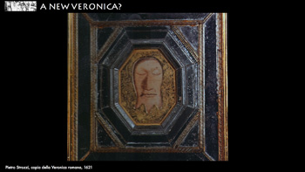 | In 1615, the imperial court in Vienna asked Paul V for a copy of the Veronica.  A year later, the pope sent a copy painted by Strozzi, which, unlike all the Veronicas from the Middle Ages, shows the face of Christ with closed eyes, as though already dead.  The new Veronica had a short life: in 1628, Pope Urban VIII ordered that all existing copies be destroyed or handed over to parish priests or bishops.  And, not long after, artists went back to painting the Holy Face with the face of the living Christ, more like the old copies.
70 | 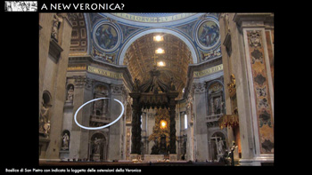 | On April 20, 1629 the balconies in the pillars by Bernini were finished. The expositions at more than 20 meters high made the Veronica practically invisible to visitors.
71 | 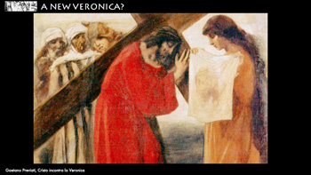 | In 1742 Benedict XIV encouraged the devotions of the Way of the Cross: from this point on, the compassionate gesture of Veronica, remembered in the sixth station, found its place again in churches.
72 | 
73 | 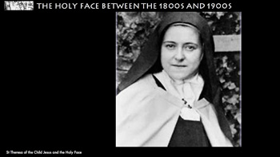 | There was a rebirth of devotion to the Holy Face thanks to a Carmelite from Tours, Sr. Marie De Saint-Pierre (1816-1848). From her work, inspired by the Veronica, the arch-confraternity of the Holy Face was born.  In 1885, Louis Martin enrolled in the Fraternity with his daughters, the youngest of whom would be raised to the altars by the name of Theresa of the Child Jesus and the Holy Face.
74 | 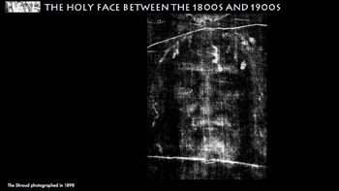 | At the turn of the twentieth century, a second factor brought attention to the face of Christ: the first photograph of the Holy Shroud of Turin.  The negative created an extremely strong reaction which immediately spread throughout the world.
75 | 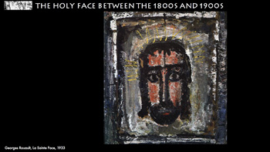 | Starting from France, then spreading everywhere, the “True Icon” became once again something that man had nostalgia for.
76 | 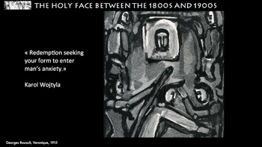 | As Karol Wojtyla wrote: (ON THE SLIDE) “Redemption seeks your form to enter every man's anxiety.”  In the first half of the twentieth century, two mystics - the Italian Maria Valtorta and Blessed Portuguese Alexandrina Maria da Costa - both declared that Veronica’s Veil would "be contemplated until the end of the world”.
77 | 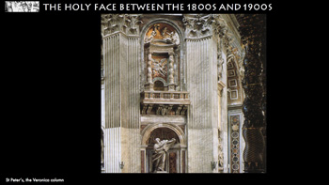 | Which veil? The Church, who has encouraged research on the Turin Shroud, has not yet allowed any photos of the Veronica still closed up in St. Peter’s. The few scholars who have seen it say that no image is visible on it. Thus confirming critics' widespread opinion that the Holy Face has been definitely lost.
78 | 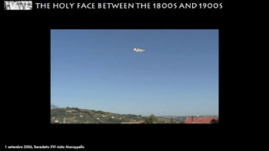 | Pope Benedict XVI, by choosing to visit Manoppello at the beginning of his pontificate, brought attention back to the Holy Face whose ‘mysterious gaze never ceases to rest on all peoples and all men’.  MOVIE
79 | 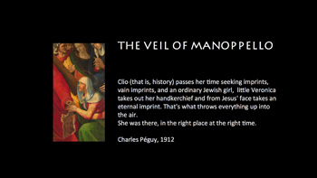 | (ON THE SLIDE) Clio (that is, history) passes her time seeking imprints,, vain imprints, and an ordinary Jewish girl, little Veronica takes out her handkerchief and from Jesus' face takes an eternal imprint. That's what throws everything up into the air.  She was there, in the right place at the right time.  Charles Péguy, 1912
80 | 
81 | 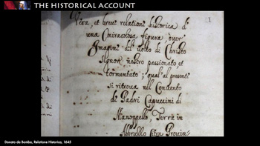 | Between 1640 and 1645, in his Historical Account, Father Donato da Bomba recorded the arrival of the Veil in Manoppello at the beginning of the 1500s and its subsequent vicissitudes, up to the point of its being given to the Capuchins.
82 | 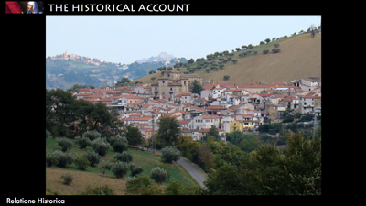 | In this document you can read that while conversing in a public square, Giacomo Antonio Leonelli was approached by a stranger who gave him a little bundle, and, without opening it, begged him to hold the object very dear. Unwrapping the cloth, Giacom’Antonio was moved, seeing the wondrous face of the Lord, but when he turned round to thank the pilgrim, he could not find him.
83 | 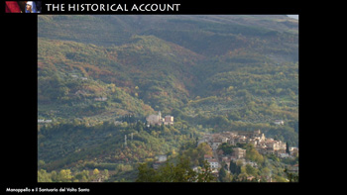 | At the beginning of the 1600s, a descendant of the Lionellis, Marzia, sold the veil to Donato Antonio de Fabritiis to pay for her husband to be released from prison. In 1638, the new owner of the veil gave it to the Capuchin convent where it is still kept.
84 |  | For four centuries the Holy Face remained as the heritage of local piety.  MOVIE
85 | 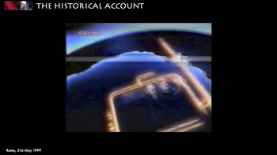 | The silence was broken on the May 31, 1999, when Fr. Heinrich Pfeiffer, a professor at the Gregorian University, proposed a revolutionary hypothesis...  MOVIE
86 | 
87 | 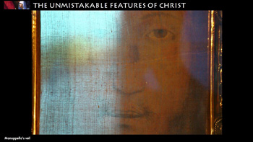 | How could Fr. Heinrich Pfeiffer have reached this conclusion?  The Holy Face of Manoppello is the only portrait on veil which has come down to us, and it is inexplicable how it could have been painted or impressed on both faces of the cloth, maintaining the transparency of the cloth.
88 | 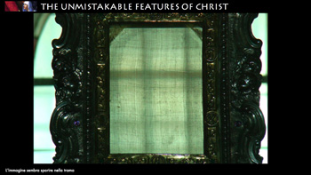 | The image appears to be one with the cloth, and it disappears into the weft of the cloth if it is looked at frontally, on both sides of the cloth.
89 | 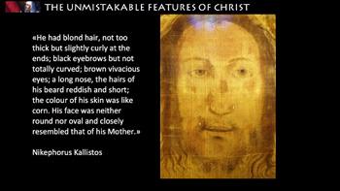 | On the face of Manoppello we can see the characteristic features of Christ described by the Fathers of the Church and summed up in the Middle Ages  (ON THE SLIDE)  “He had blond hair, not too thick but slightly curly at the ends; black eyebrows but not totally curved; brown vivacious eyes; a long nose, the hairs of his beard reddish and short; the color of his skin was like corn. His face was neither round nor oval and closely resembled that of his Mother.”
90 | 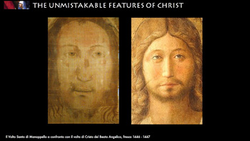 | It is surprising to note the correspondence between the Face of Manoppello and the faces of Christ painted by artists who were pilgrims to Rome.  Take this fresco by Beato Angelico who arrived in Rome in 1445.
91 | 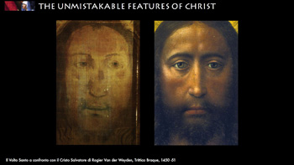 | And the Flemish artist Rogier Van der Weyden who painted Christ the Savior after a pilgrimage to Rome for the 1450 Jubilee.
92 | 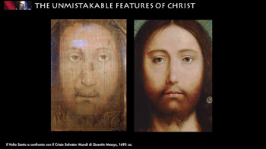 | Van der Weyden’s drawings were taken as a model by the Flemish School of painters ...
93 | 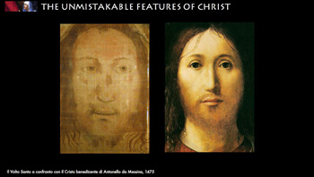 | ... and by Antonello da Messina.
94 |  | Now we will identify in the Manoppello veil the characteristic traits of the other acheiropoieta of Christ...
95 | 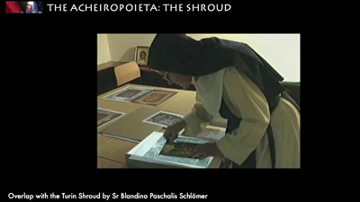 | Firstly, with the one which is perhaps the only image not made by human hands which has come down to us, the Turin Shroud. The studies of Sr Blandina Paschalis Schlömer have shown a close relationship between the faces which allows for their total overlap. MOVIE
96 | 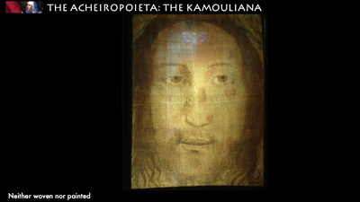 | What we know about the Kamouliana is that the face seemed to be “neither woven nor painted”.  Although it looks like a painting from the 1400s, the Manoppello veil has characteristics which seem incompatible with any painting technique.
97 | 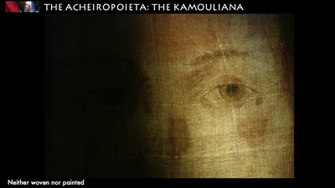 | Until now, the tests which have been carried out (without taking the veil out of its glass frame from the 1600s, so as to not upset the equilibrium of the cloth) have not been able to establish the nature of the image.
98 | 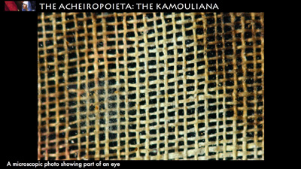 | The threads of the veil are one millimeter in diameter with a space of two millimeters. The extraordinary transparency of the veil is given by the prevalence of the empty spaces, confirmed by optical tests which, in only a few places, have shown traces of some kind of substance (perhaps dirt, or glue?).
99 | 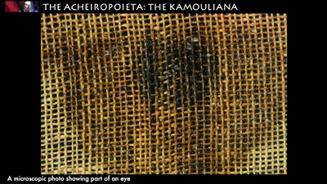 | Residue of color seems to be denser in the spaces between the warp and the weft in the pupils of the eye; in other places it underlines the shape of the face.  However, ultraviolet light analyses have failed to find the florescence which signals the presence of an amalgamation of colors in the cloth and in the image.
100 | 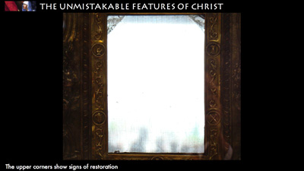 | Whereas in the upper corners there are clear signs of restoration where there is a definite fluorescence. Infrared light analyses have shown that there are no signs of a draft or of corrections under the image.
101 | 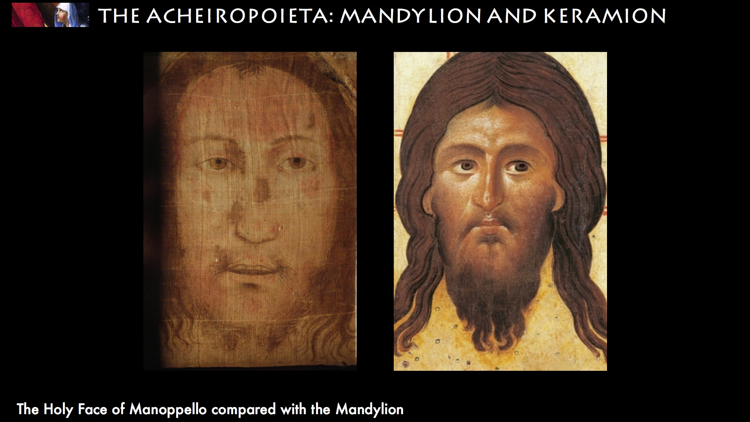 | We’ve seen that the differences between the Mandylion and the Keramion lie in the direction of the gaze and in the little tuft of hair falling onto the face, which indicate that one is a mirror image of the other.  The Veil of Manoppello is equally visible on both sides and thus contains within it both the Mandylion, which looks right...
102 | 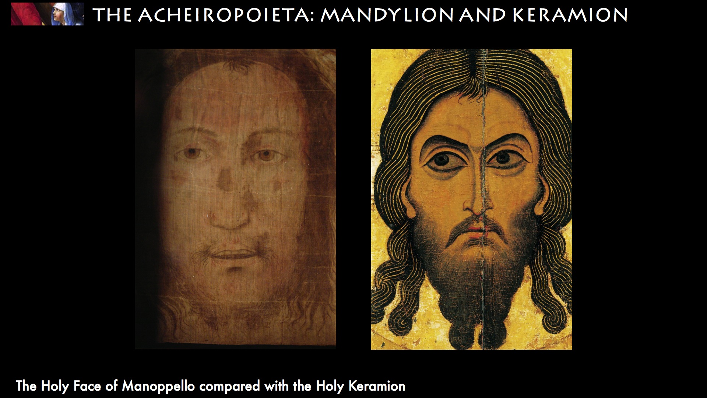 | ...and the Keramion with the gaze and tuft of hair to the left.
103 | 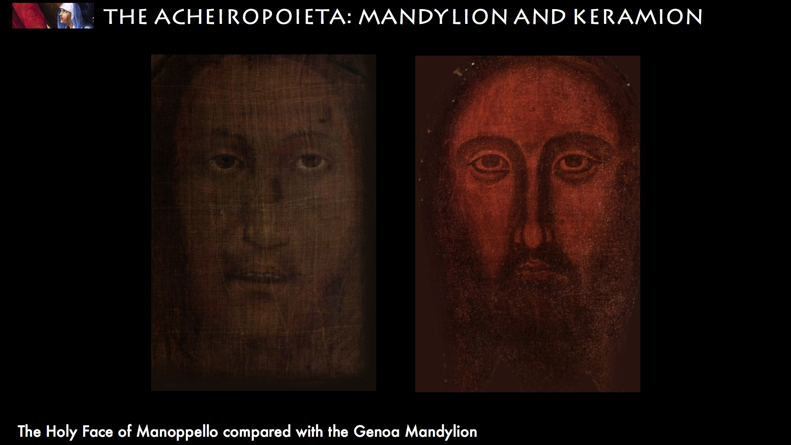 | Moreover, when the light veil is placed on a black background, the flesh colour disappears and only the corneas of the eyes emerge, producing a notable resemblance to the Mandylion of Genoa. This is what could have been described by Luther in 1510: “Poor Hans cannot have seen anything more than a piece of transparent cloth covering a black board.”
104 | 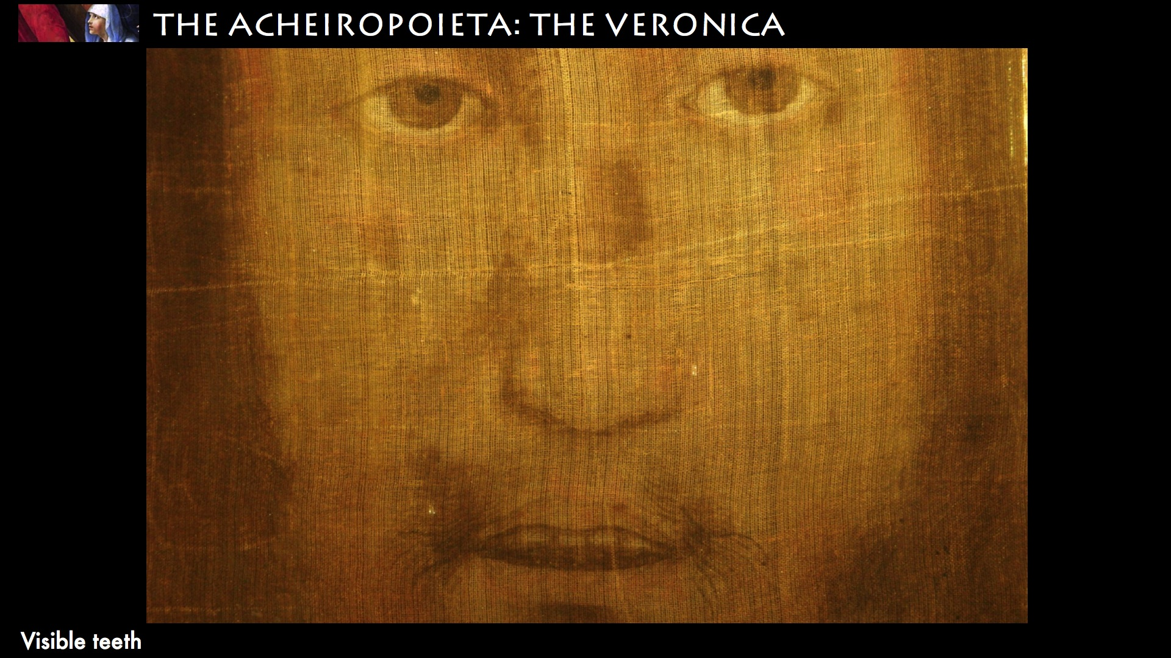 | In the Manoppello veil we can also see the characteristics of the Roman Veronica. Firstly, the open mouth with visible teeth.
105 | 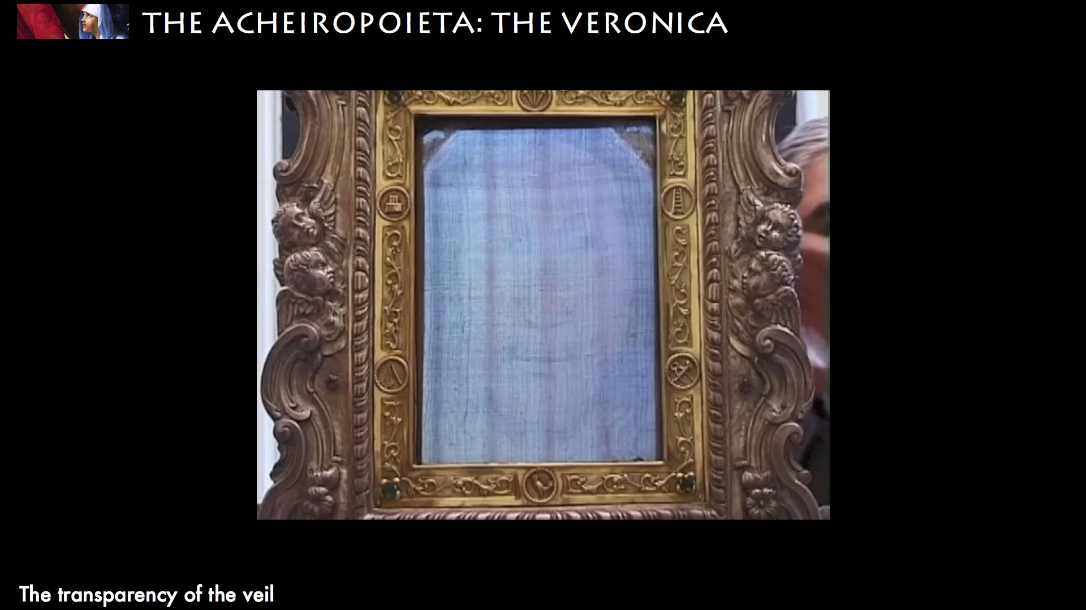 | The transparency of the veil underlined by the artists in the copies of the Veronica is found ‘real’ in the Manoppello veil.  As you can see in the video, the veil is of such a bright material that the face is visible only if a background is created behind it.  MOVIE
106 | 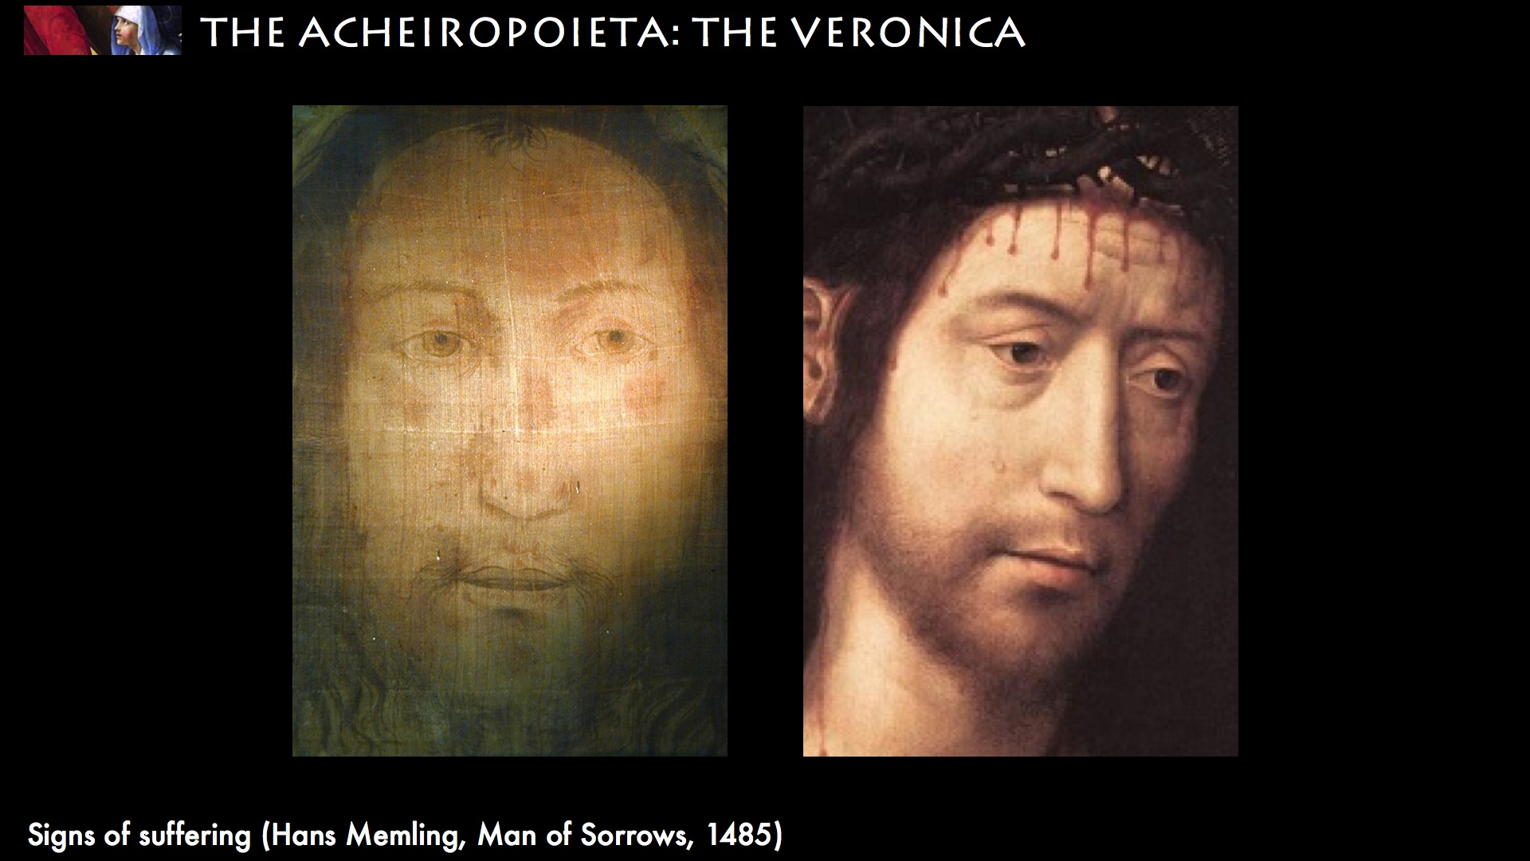 | Lastly, the Holy Face of Manoppello carries signs of suffering. The wounds are the same as in the Turin Shroud: the nose is offset, the cheek is deformed, there’s a clear hematoma on the cheekbone, the mouth is swollen and bloody.
107 | 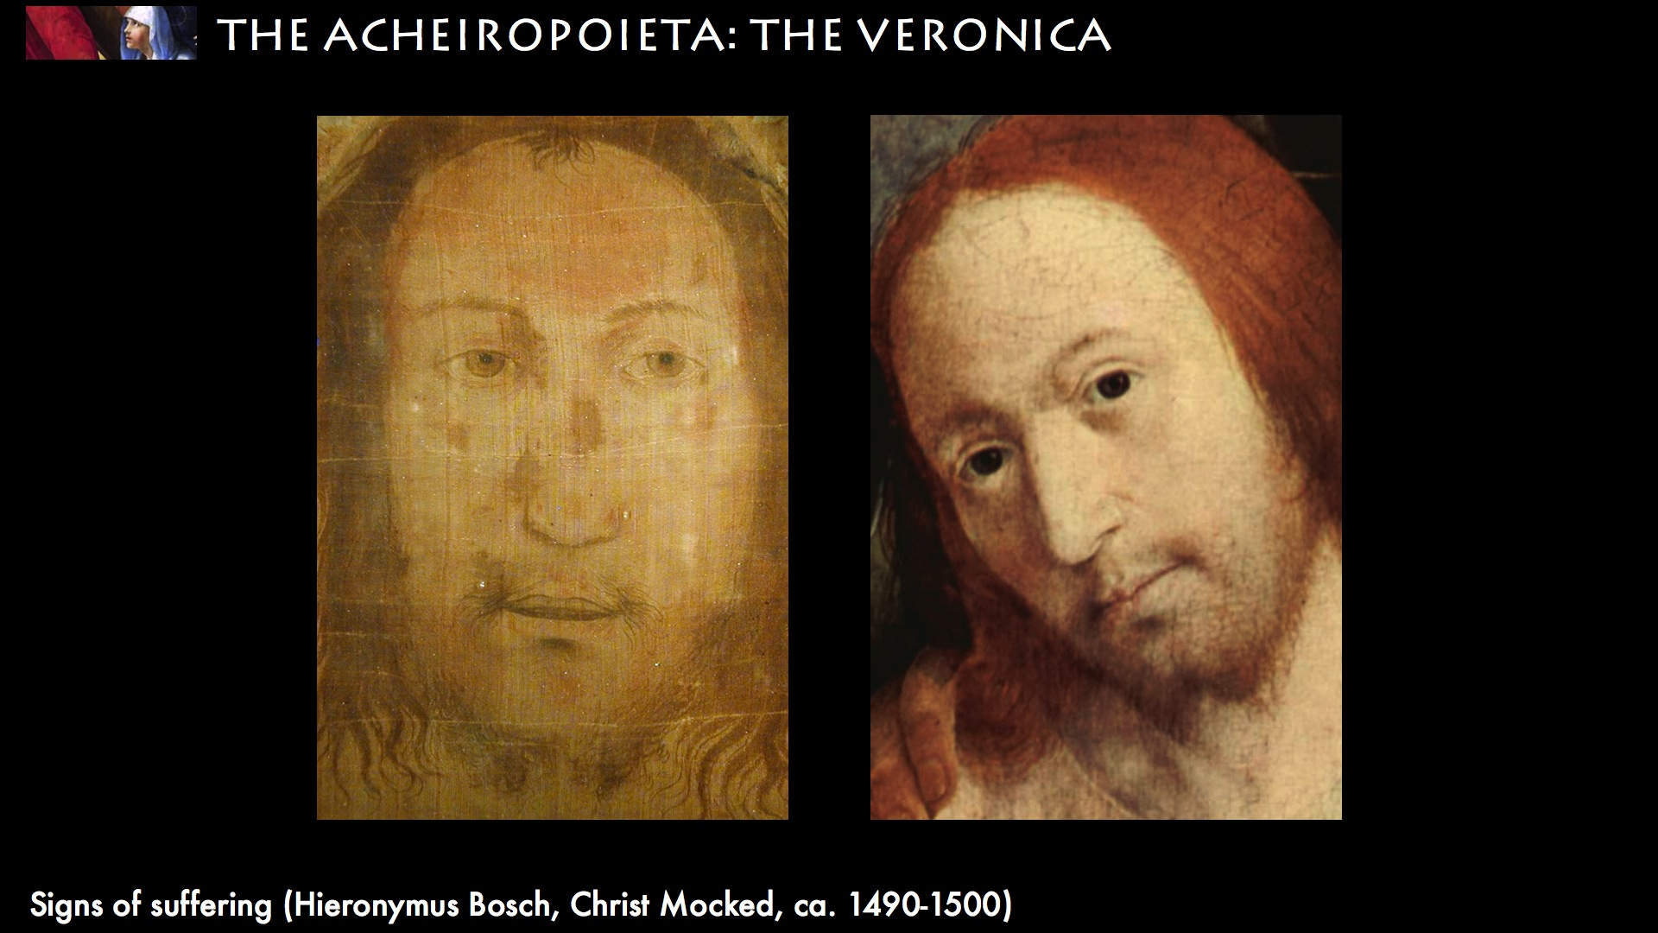 | The thin beard has been torn as Isaiah prophesied.
108 | 
109 | 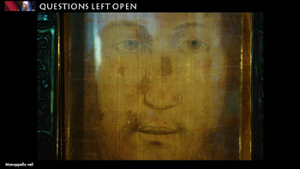 | These correspondences give weight to Fr. Pfeiffer’s hypothesis according to which the Manoppello Veil can be identified with the Veronica in Rome. Is there perhaps any other object that is so refined and which corresponds to the hymn Salve Sancta Facies, written in the 1300s? Historical research which is testing this hypothesis is still in its infancy.  But this is not the only question left open.  From the optical studies, we await data about the way in which the image was formed on the Veil, on the nature of the cloth (in 2007 it was hypothesized that it could be made from marine byssum, and the relation with the Turin Shroud.
110 | 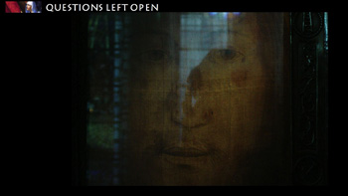 | And if it were possible to ascertain that the Manoppello veil were not realized by human hands, there remains the question posed by Emperor Constantine VII, reproposed by Olivier Clément during the Via Crucis at the Colisseum in 1998: What is the origin of the Holy Face?
111 | 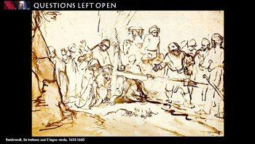 | Is it the gift to a King from Edessa,  or the reward for the compassionate gesture of a woman on the steep way to Calvary  …
112 | 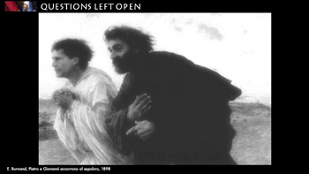 | ...or the sudarium burned by the Spirit that Peter and John saw in the tomb on Easter morning?
113 | 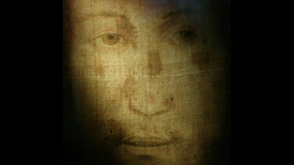 | (pause)  The aim of the exhibition has been to know the history of the portraits of Christ and understand what this particular gift that Christ left his Church might mean for us. We can find many answers to this question scattered throughout the centuries.  Here are two.
114 | 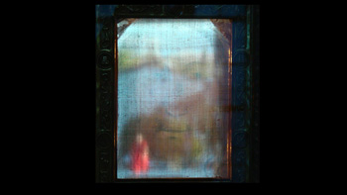 | The first can be read in the Revelations to St. Brigid, who was in Rome during the Holy Year of 1350. During the exposition of the Veronica, she found herself next to a Danish knight who did not believe that the veil was the sudarium of Veronica and considered it folly to venerate it. St. Brigid stopped to pray and Jesus replied: “What did that pompous windbag tell you? Was it not that many people have doubts about the truth of the relic of my face cloth? I assure you that this sweat flowed from my face onto the cloth because of the quality of the woman who prayed to me and for the solace of future generations.”
115 | 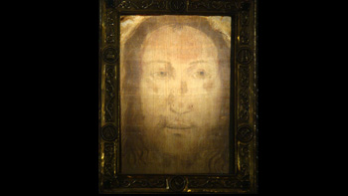 | The second, which complements the first, is reported by Blessed Pierina de Micheli in 1936:  “Whoever gazes upon me, already consoles me”

